**Self-review: Defining resources and themes**

1. When defining the color resource in the exercise, what class was used?

1. ColorCompose
2. ColorYellow
3. Color

2. What was the size of the order button?

1. 200 sp
2. 200 dp
3. The Text size was derived from size of the text.

3. Which Theme color was modified?

1. primary
2. secondary
3. tertiary

1-b 2-b 3-a

# Knowledge check: Themes

1. Theme is represented as a collection of attributes.

1. True
2. False

2. Modifying Button style in the theme will not change appearance of every button in the application unless theme style is overridden.

1. True
2. False

3. Select all that apply.

1. The Button height defined in app Theme can be overridden in__________:
2. Button Style
3. Android Manifest
4. Button composable

4. What do these two characters of hexadecimal ARGB color represent?

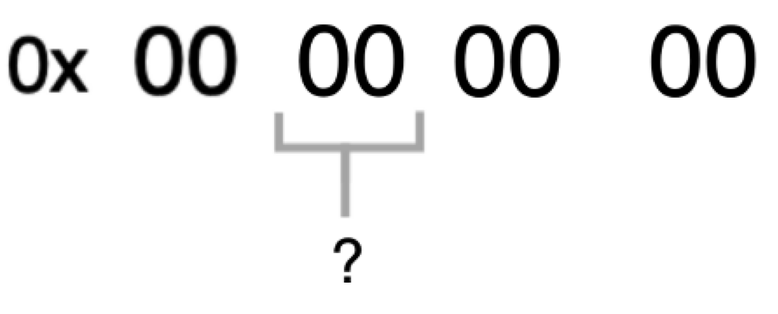

1. Value of blue color
2. Value of green color
3. Value of alpha channel
4. Value of red color

5. The Decimal numeric system is used to represent Android color resources.

1. True
2. False

6. Which unit would you use to set text size?

1. sp (scalable pixel)
2. dp (density independent pixel)
3. both sp and dp can be used

7.Which arguments of text can be provided using Text composable? Select all that apply.

1. font size
2. letter spacing
3. font color
4. font weight

8. The White color is represented by __________- value in the ARGB color space.

1. FF000000
2. FFFFFFFF
3. 00FF0000
4. 0x00000000

1-a 2-b 3-a,c 4-d 5-b 6-a 7-a,b,c,d 8-b

# Self-review: Animating composables

1. What is the name of the composable used to add text visibility animations?

**AnimatedVisibility**

**Visibility**

**Visible**

**2.** What is the name of the enter transition that was added to the text?

fade out

slide in

fade in

3.**remember** delegate preserves visible variable state during recomposition.

True

False

1-a b-c c-a

# Animations

1. Which of the following contains styles for buttons, lists, grids, images and many other composables?

**Theme**

composables

material components

UI elements

2. .Which color is represented by the following hexadecimal value?

**0xFF000000**

white

black

gray

blue

3. True or False: The main difference between **dp** (density independent pixel) and **sp** (scalable pixel) is that it takes the text size setting of the user device into consideration when deciding what text size should be displayed.

True

False

4. Which of the following correctly creates a text composable with underlined text?

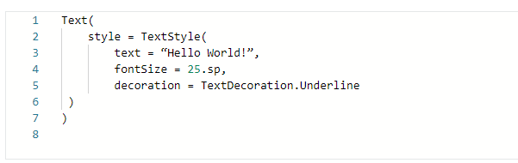

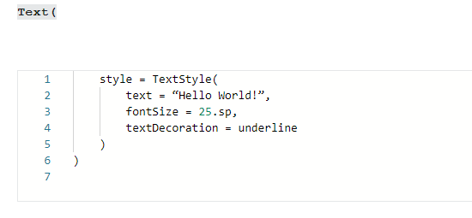

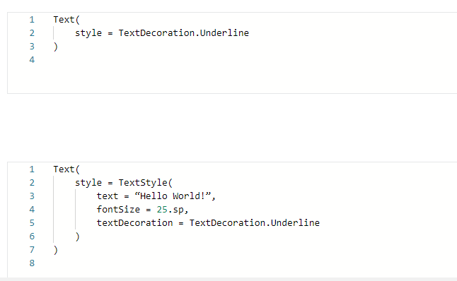

5. Which of the following correctly adds **Text** composable as the content for a **Surface**?

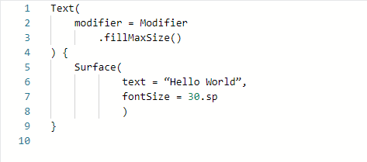

6. Which of the following is an optional modifier that can be used to specify the size of text within a **Text** composable?

**fontWeight**

**fontSize**

**text**

**fontColor**

7. Is it possible to change the shape of **Surface** corners?

Yes

No

8.Which of the following is the composable that animates the appearance and disappearance of its content?

**VisibleAnimation**

**Animation**

**AnimatedVisibility**

**Visibility**

9. Which of the following will make the text “Hello World” instantly visible or invisible after a button click?

a)

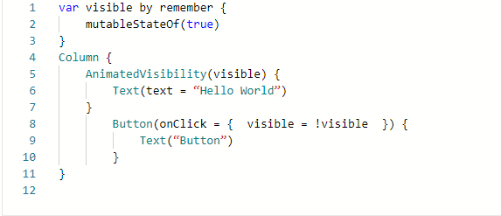

b)

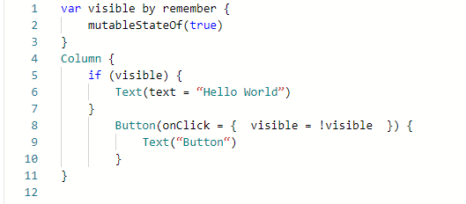

c)

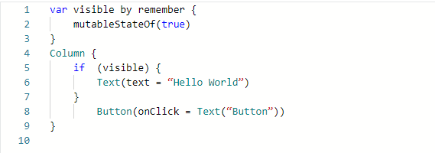

d)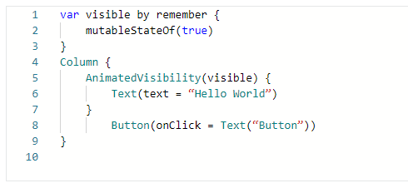

10. True or False: You can control how long each transition will last.

1. True
2. False

1-c 2-b 3-b 4-d 5-a 6-b 7-a 8-c 9-b 10-a